Training of Trainers (ToT) on Violence against children and women (VACW) and harmful practices (HP) prevention program: Journey of Life, a community-led approach to child protection
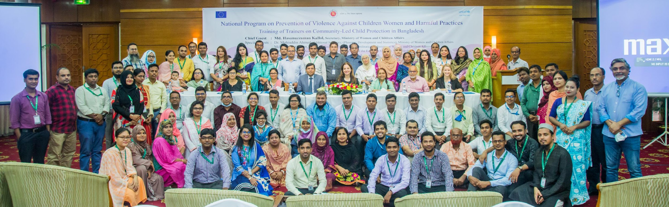

Venue: Bangabandhu International Conference Center, Dhaka
Date: September 25 – 28, 2022

Background

From September 25th to 28th, a four-day long training on the Journey of Life, Connection Module, and Community Based PSS for protecting children and adolescents from any sets of violence under MoWCA was held at Bangabandhu International Conference Center in Dhaka. These modules were adjusted to the context in Bangladesh to capacitate children and community people to identify the need and problems of children to find the solution through a community-led approach. The knowledge and skills delivered on child protection will help parents and community members understand the protection context and provide children including adolescents with a safer place inside and outside the home. The training aimed to capacitate Violence Against Children and Women Program Coordinators (VACW PCs) Child Rights Facilitators (CRFs), Harmful Practice Program Coordinators (HPPC), and Community Mobilizers (CMs) to cascade the Journey of Life (JoL) training to front liners across the country.

Participants: UNICEF Child Protection Team including Natalie McCauley (Chief of Child Protection) and Elisa Calpona (Child Protection Manager and lead for VACW and HP prevention program), Child Protection Officers (CPOs), Violence Against Children and Women Program Coordinators (VACW PCs), Harmful Practice Program Coordinators (HPPCs), Child Rights Facilitators (CRFs) & CP Community Mobilizers (CP-CM). In total, 90 participants received this training in three separate venues at BICC.

Day 1

Opening Remarks

The workshop program started with registration, a group photo and opening remarks by Mr. S.M. Latif (Project Director of Accelerating Protection for Children) and Ms. Elisa Calpona (Child Protection Manager, UNICEF Bangladesh) .

S.M. Latif, Project Director for Accelerating Protection for Children, welcomed participants and thanked all attendees for coming and UNICEF for supporting them. He explained that the Secretary would be present for the formal inauguration in the afternoon, and credited the fresh momentum to the project with the arrival of Ms. Elisa Calpona from UNICEF. | 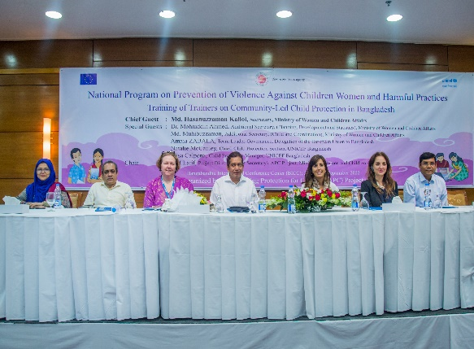

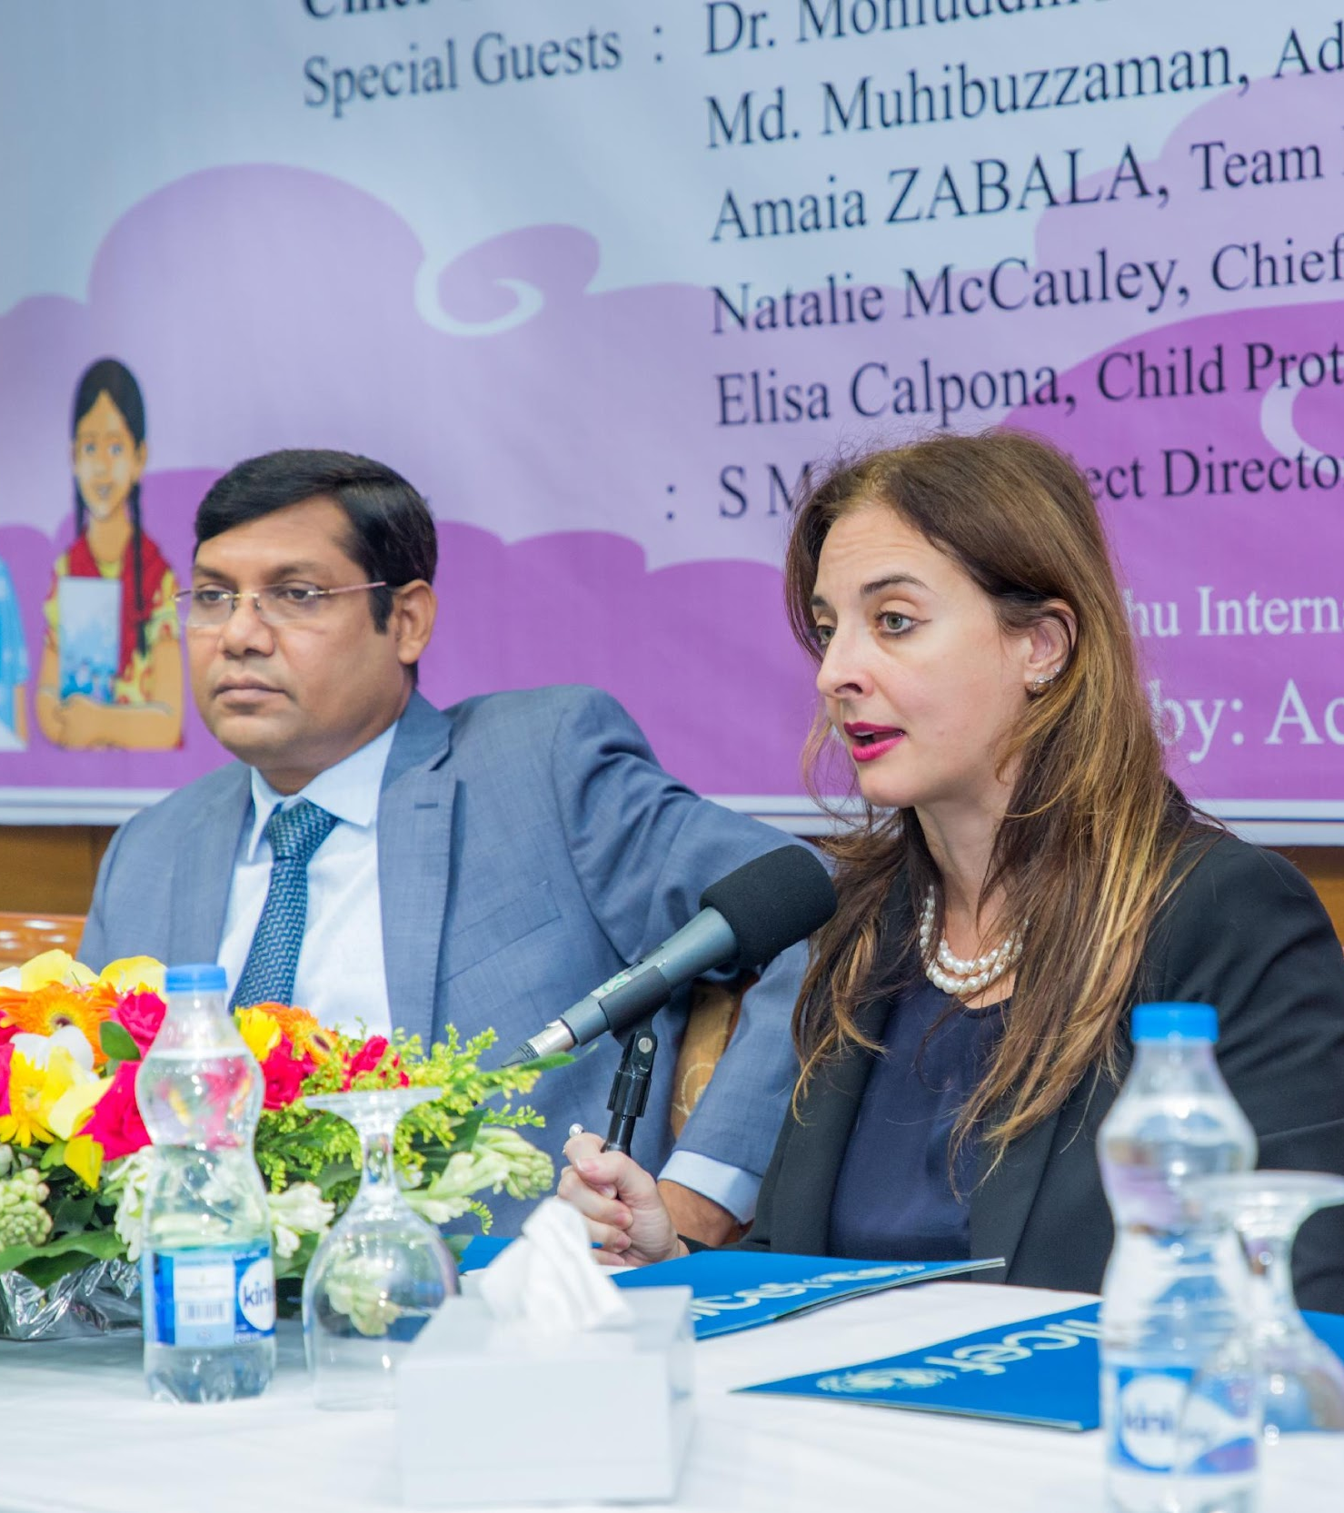 | Elisa Calpona, Child Protection Manager from UNICEF, thanked Mr. Latif for his kind words and expressed that she has been grateful since her arrival in Bangladesh to be able to invest in a promising programme like this. Having the chance to revise the programme in 2021 in line with the new UNICEF Country Programme has presented many opportunies. The programme is now nationwide and supported by the EU. She spoke to the situation of children in Bangladesh – with 45 million experiencing violence and 51% of girls aged 9-18 married. Ms. Calpona stated that UNICEF’s commitment under the MoWCA and other ministries is to understand key entry points to fight violence against children and women and harmful practices. She ended by expressing that the participants present today are the key actors that will roll these trainings out, and specifically thanked the VACW Coordinators, Community Mobilizers, and HP Programme Coordinators.
Session 1: Introduction

After the opening session, MDF (professional capacity development firm) began the four-day long training on the Journey of Life, Connection Module and Community Based PSS for protecting children and adolescents from any sets of violence under the APC project, MoWCA.

At the beginning of the training, MDF facilitated a session overviewing expectations and objectives, how to prepare the community before starting a session, and what to consider during facilitation with communities at the field level. Facilitators shared an overview of what participants would learn by the end of the 4-day training. Participants were split into groups and everyone wrote down their expectations for the training.

The session emphasized that when conducting sessions with a community, trainers must be actively facilitating understanding, addressing eagerness of the community, making sessions participatory, building trust, understanding the specific context (norms, culture and religious belief) of each community, being non-judgmental, and being prepared. Specific skills and techniques for facilitation of the modules were covered:  - Rules for conduction of group work  - Techniques on asking questions  - Facilitation team coordination and dynamics  - How to encourage participant’s participation  - Non-verbal facilitation communication | 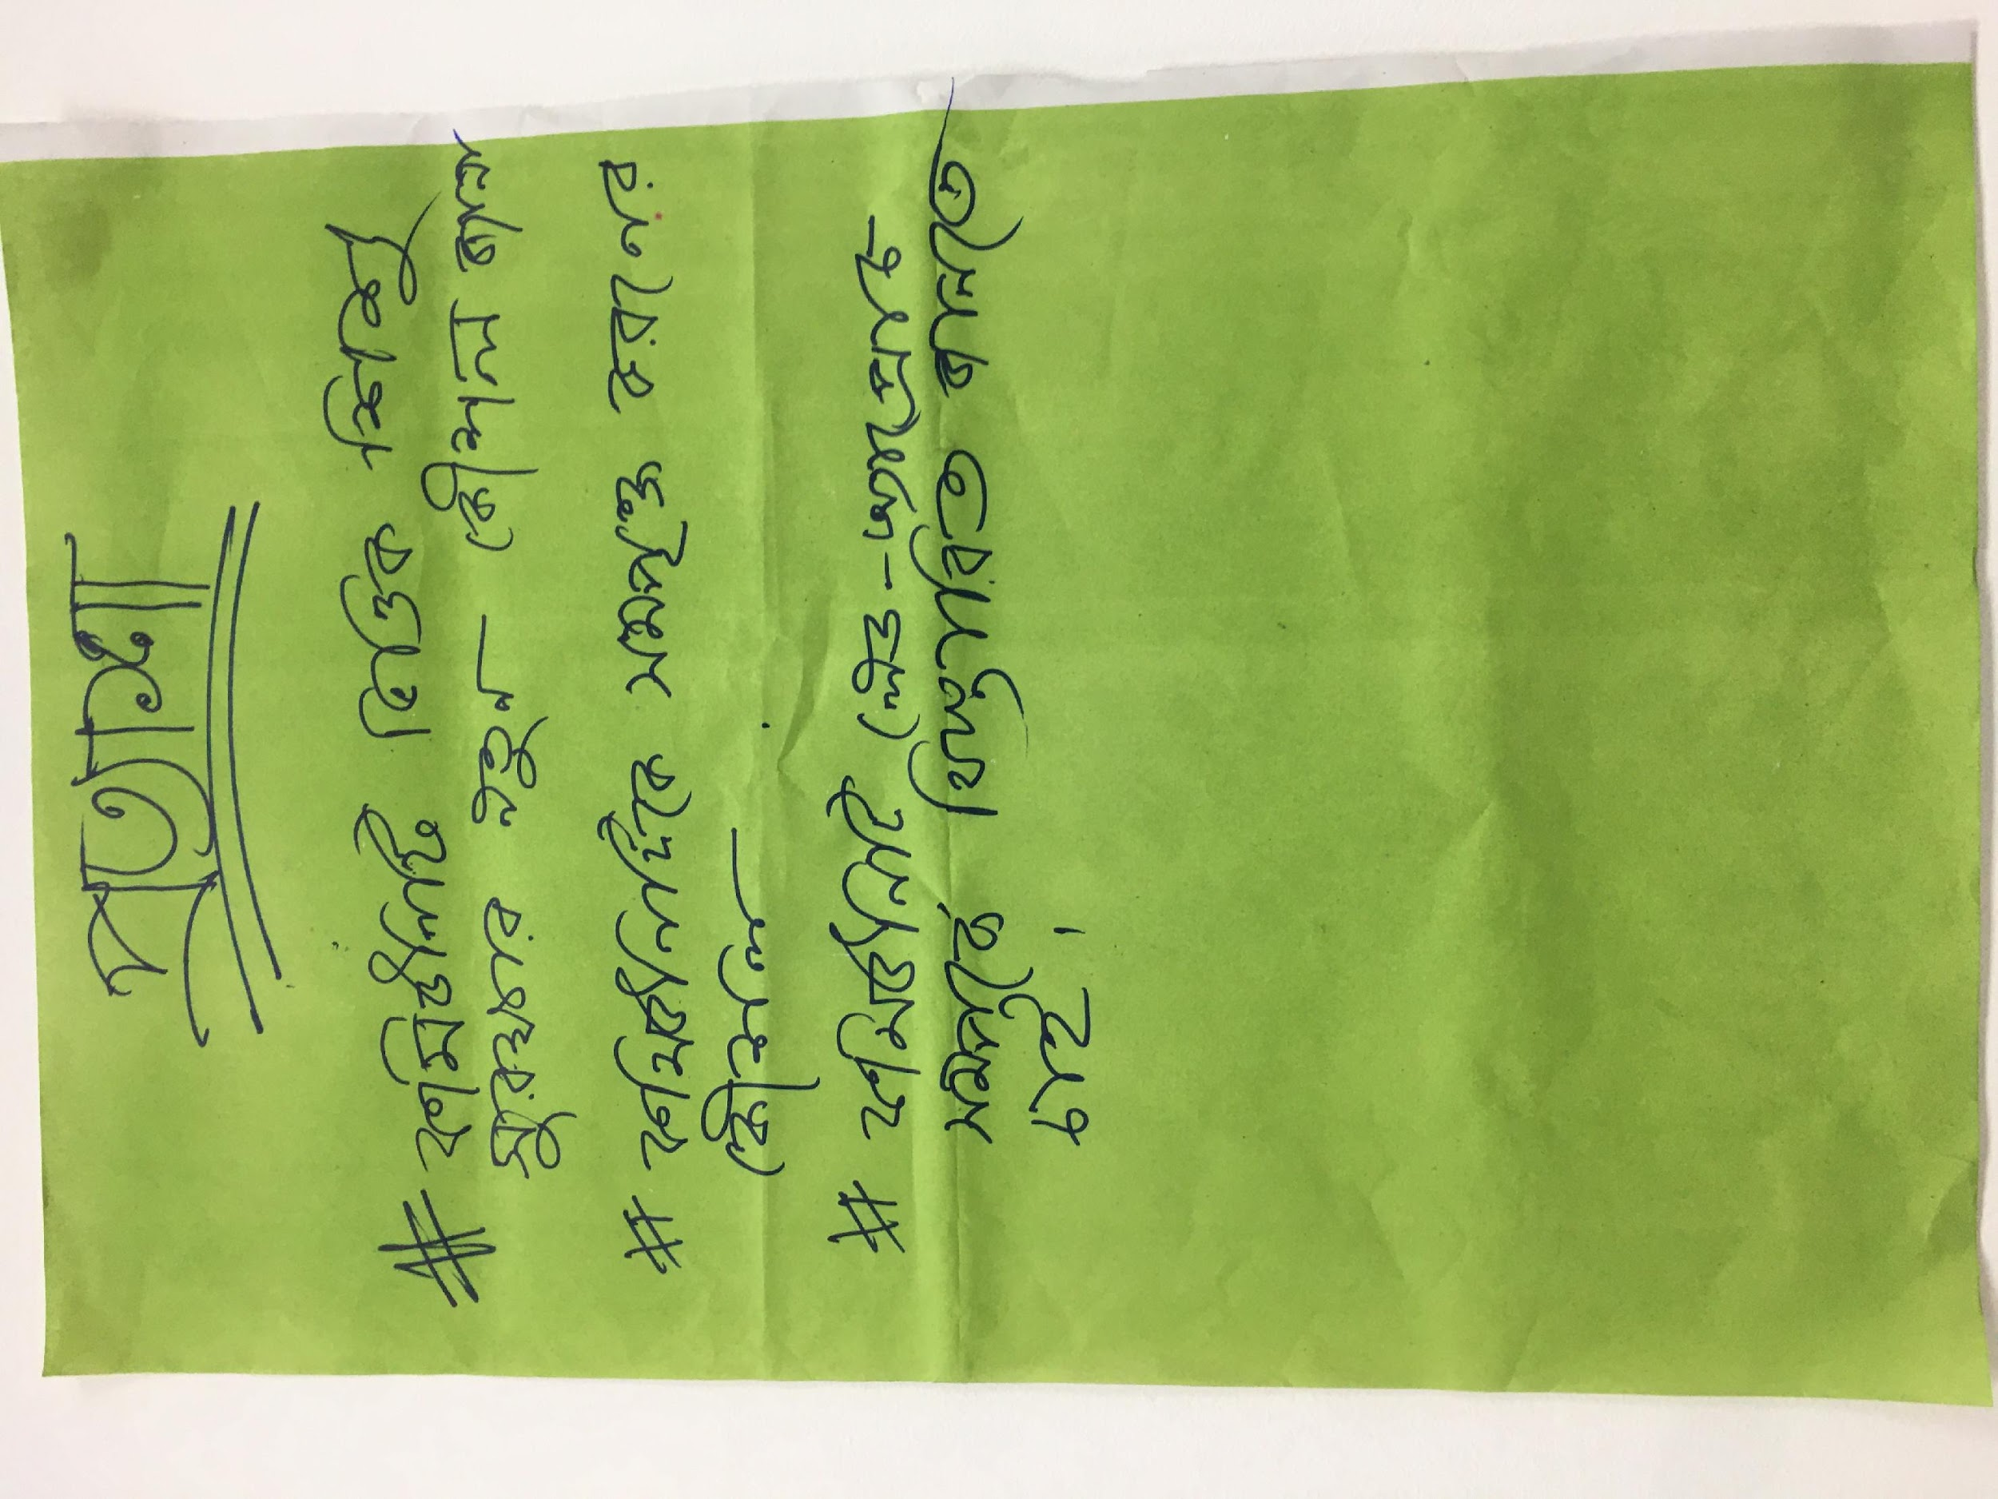

Following this conversation, every table wrote down a different role of a facilitator, and then discussed different challenges to facilitators and how to remedy them. The session ended by having every participant share what they wanted to improve about themselves as a facilitator.

Laptop Handover Ceremony

In the afternoon, Mr. Hasanuzzaman Kallol, the Secretary of MoWCA, Amaia Zabala, Team Leader at the European Union to Bangladesh, Natalie McCauley, Chief of Child Protection with UNICEF Bangladesh, Elisa Calpona, CP manager and S.M. Latif, Project Director of Accelerating Protection for Children gathered to handover laptops to Harmful Practice Programme Coordinators and Child Rights Facilitators of the APC Project under MoWCA. | 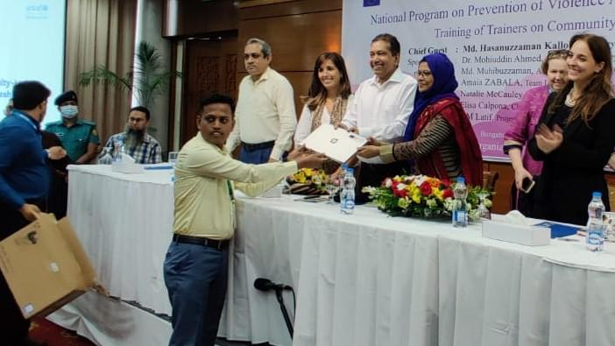

Mr. Hasanuzzaman Kallol, the Secretary of MoWCA, shared his love for children and the unique examples of children, especially girls, excelling through a protective environment. He announced that the new laptops would help all Child Rights Facilitators with their professional work and encouraged everyone in the field to continue working vigorously to reach as many children as possible. The big targets for these projects are informed by the SDGs to achieve a violence free society by 2030. He ended by expressing sincere appreciation to the EU for their financial support and UNICEF (including UNICEF-seconded VACW Coordinators) for the technical support in realizing this programme.

S.M. Latif, Project Director of Accelerating Protection for Children with MoWCA, spoke about how by working together the programme is able to reach the entire country. He shared the importance of reaching parents as well as children to facilitate meaningful change. Building off of this, he emphasized how the use of laptops will help Child Rights Facilitators materialize the results of their fieldwork.

Natalie McCauley, Chief of Child Protection with UNICEF Bangladesh, outlined the situation of violence in Bangladesh and the importance of this training in rolling out a community-led and community-owned approach to preventing violence against children and women and harmful practices.

Amaia Zabala, Team Leader at the European Union to Bangladesh, emphasized the transformative approach of the programme and its far-reaching impacts in the field to reach the most vulnerable children and adolescent across the country.
Following the speeches, the official handover of the laptops began. Mr. Hasanuzzaman Kallol, the Secretary of MoWCA, Amaia Zabala, Team Leader at the European Union to Bangladesh, Natalie McCauley, Chief of Child Protection with UNICEF Bangladesh, and S.M. Latif, Project Director of Accelerating Protection for Children handed over the laptops. In total, 60 laptops were handed over to improve the ability of field staff of adequately record and refer child protection concerns.
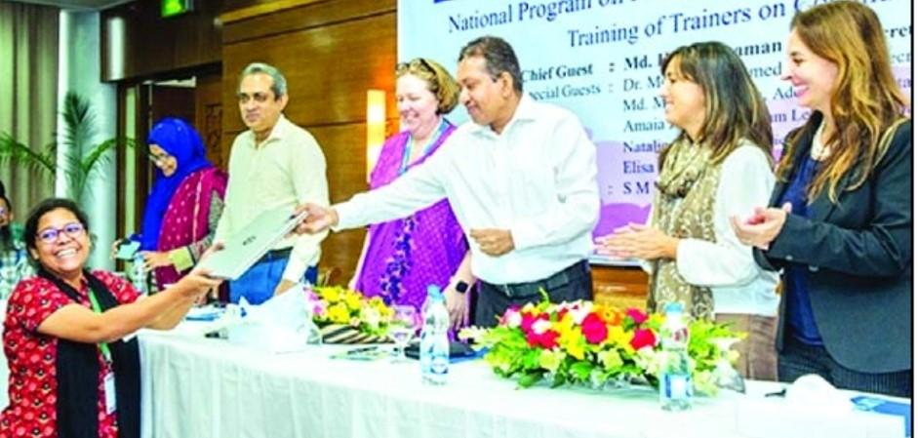
Harmful Practice Program Coordinator received a laptop from Mr Hasanuzzaman Kallol, Secretary of MoWCA.

Session 2: Working with Limited Resources

Following the laptop handover, participants reconvened to have a discussion about the importance of not making any participants feel as though there was a ‘right’ or ‘wrong’ answer. The facilitators led a lengthy discussion about how to work with little resources and how to ensure the inclusion of all participants, with extensive group work so that participants could properly grasp the concepts.

Day 2
Recap Session
The second day began with a recap session training participants to share their learning in a questions & Answer session in a group exercise. Key learnings were;

Facilitation skills and attitude of facilitators:
  - Guidance to follow during session conduction at the community level as a facilitator
  - Understanding facilitation skills; grabbing the eagerness of the community, making sessions participatory, building the trust of the participants
  - Understanding the specific context (norms, culture and religious belief) of each community
  - Being non-judgmental, being prepared and flexible to learn from the community

Specific skills and techniques for facilitation of the JoL module were covered as below:
  - Rules for conducting of group work
  - Techniques for asking questions
  - Facilitation team coordination and dynamics
  - How to encourage active participation of community members
  - Non-verbal facilitation communication

Session 3: Introduction to the Journey of Life (JoL) Modules
Firstly, the Facilitator introduced the JoL and explained the background that led to a community-led and community-owned approach

The Content of the Modules were outlined as below:
Session 1: Introduction and Welcome
Session 2: Introducing the Journey of Life
Session 3: Meeting Children Needs
Session 4: Understanding Children’s Problems
Session 5: Identifying Children Who Need Help
Session 6: Building Children’s Strengths
Session 7: Get Involved
Session 8: Evaluation of the Training

Session 4: Mind Mapping
After the introduction, the first session began with mind mapping by each participant, considering their good and bad feeling feelings during their childhood by following a pictorial method. Then, plenary discussion took place where participants showed their pictures and shared good and bad feelings, and the support that they had needed during that period. Key learnings from this session were that support from the community and family was needed to manage and handle the challenges children faced. Participants agreed that they had learnt many lessons from their practical journey of life session and would utilize their experiences to help children grow and develop.

Session 5: Building a Child (Children Need Identification)
This session was facilitated through group work. Each group identified children’s needs by using a drawing method instead of writing any word. Afterwards, each group presented their group work

In a summary, participants presented what they had drawn to build a child (which worked to identify children’s needs):  - Birth registration  - Nutritious food  - Pure drinking water  - Primary health treatment  - Friends  - Quality Education  - School, Madrasah  - Playground  - Safety  - Love and affection | 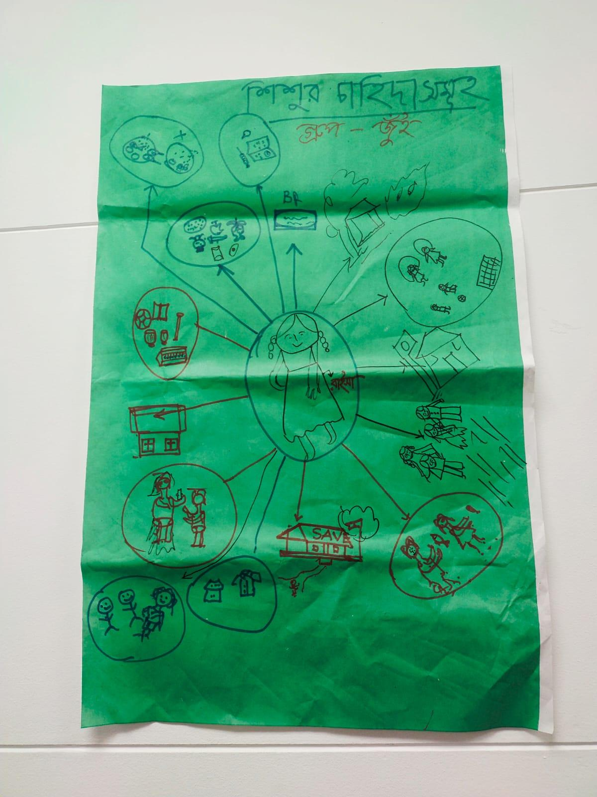

Session 6: Cost Analysis to Meet Children’s Needs

Based on the children’s needs identified in the previous session, the facilitator encouraged participants to think about whether each need required money or people. Originally, most of the participants indicated that the needs required money and people. However, after extensive discussion, the participants concluded that people will play the most influential role in meeting the needs of children.

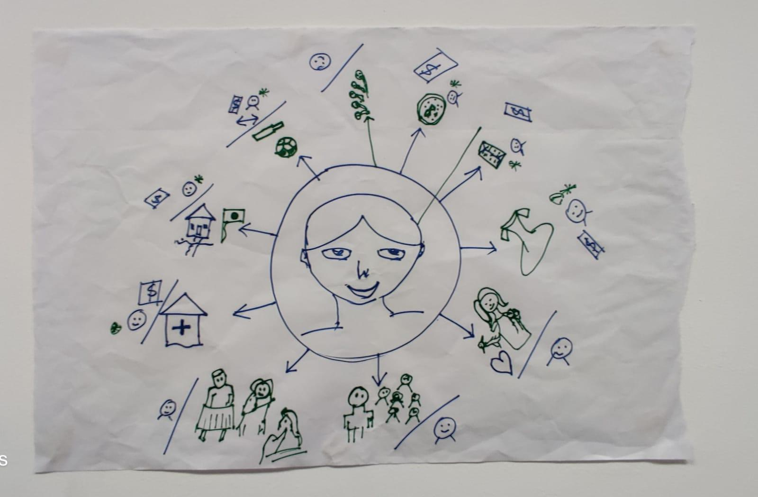 | Among the participants, many were confused about the difference between a problem and a need. In this regard, Natalie McCauley, Chief of Child Protection for UNICEF, offered clear guidance to the participants and they were able to differentiate between the two concepts.

Day 3

Session 7: Understanding Children’s Problems
Day 3 began with a focused discussion on understanding children’s problems. This was followed by group work, after which each group presented their work in plenary and received feedback from other groups. After that, participants worked together to identify the top 5 children’s problems. The identified problems were;  - Family violence  - Mental pressure  - Child marriage  - Gender-based discrimination & Violence  - Sextual harassment  - Child labour  - Low interest to meet children’s needs  - Lack of recreational arrangements  - Respect for children’s opinions  - Lack of child participation  - Child protection  - Bulling  - Drowning  - Corporal punishment  - Lack of positive parenting  - Online bulling  - Week Community Based Child Protection System  - Lack of better implementation of Children Act 2013  - Early Affairs | 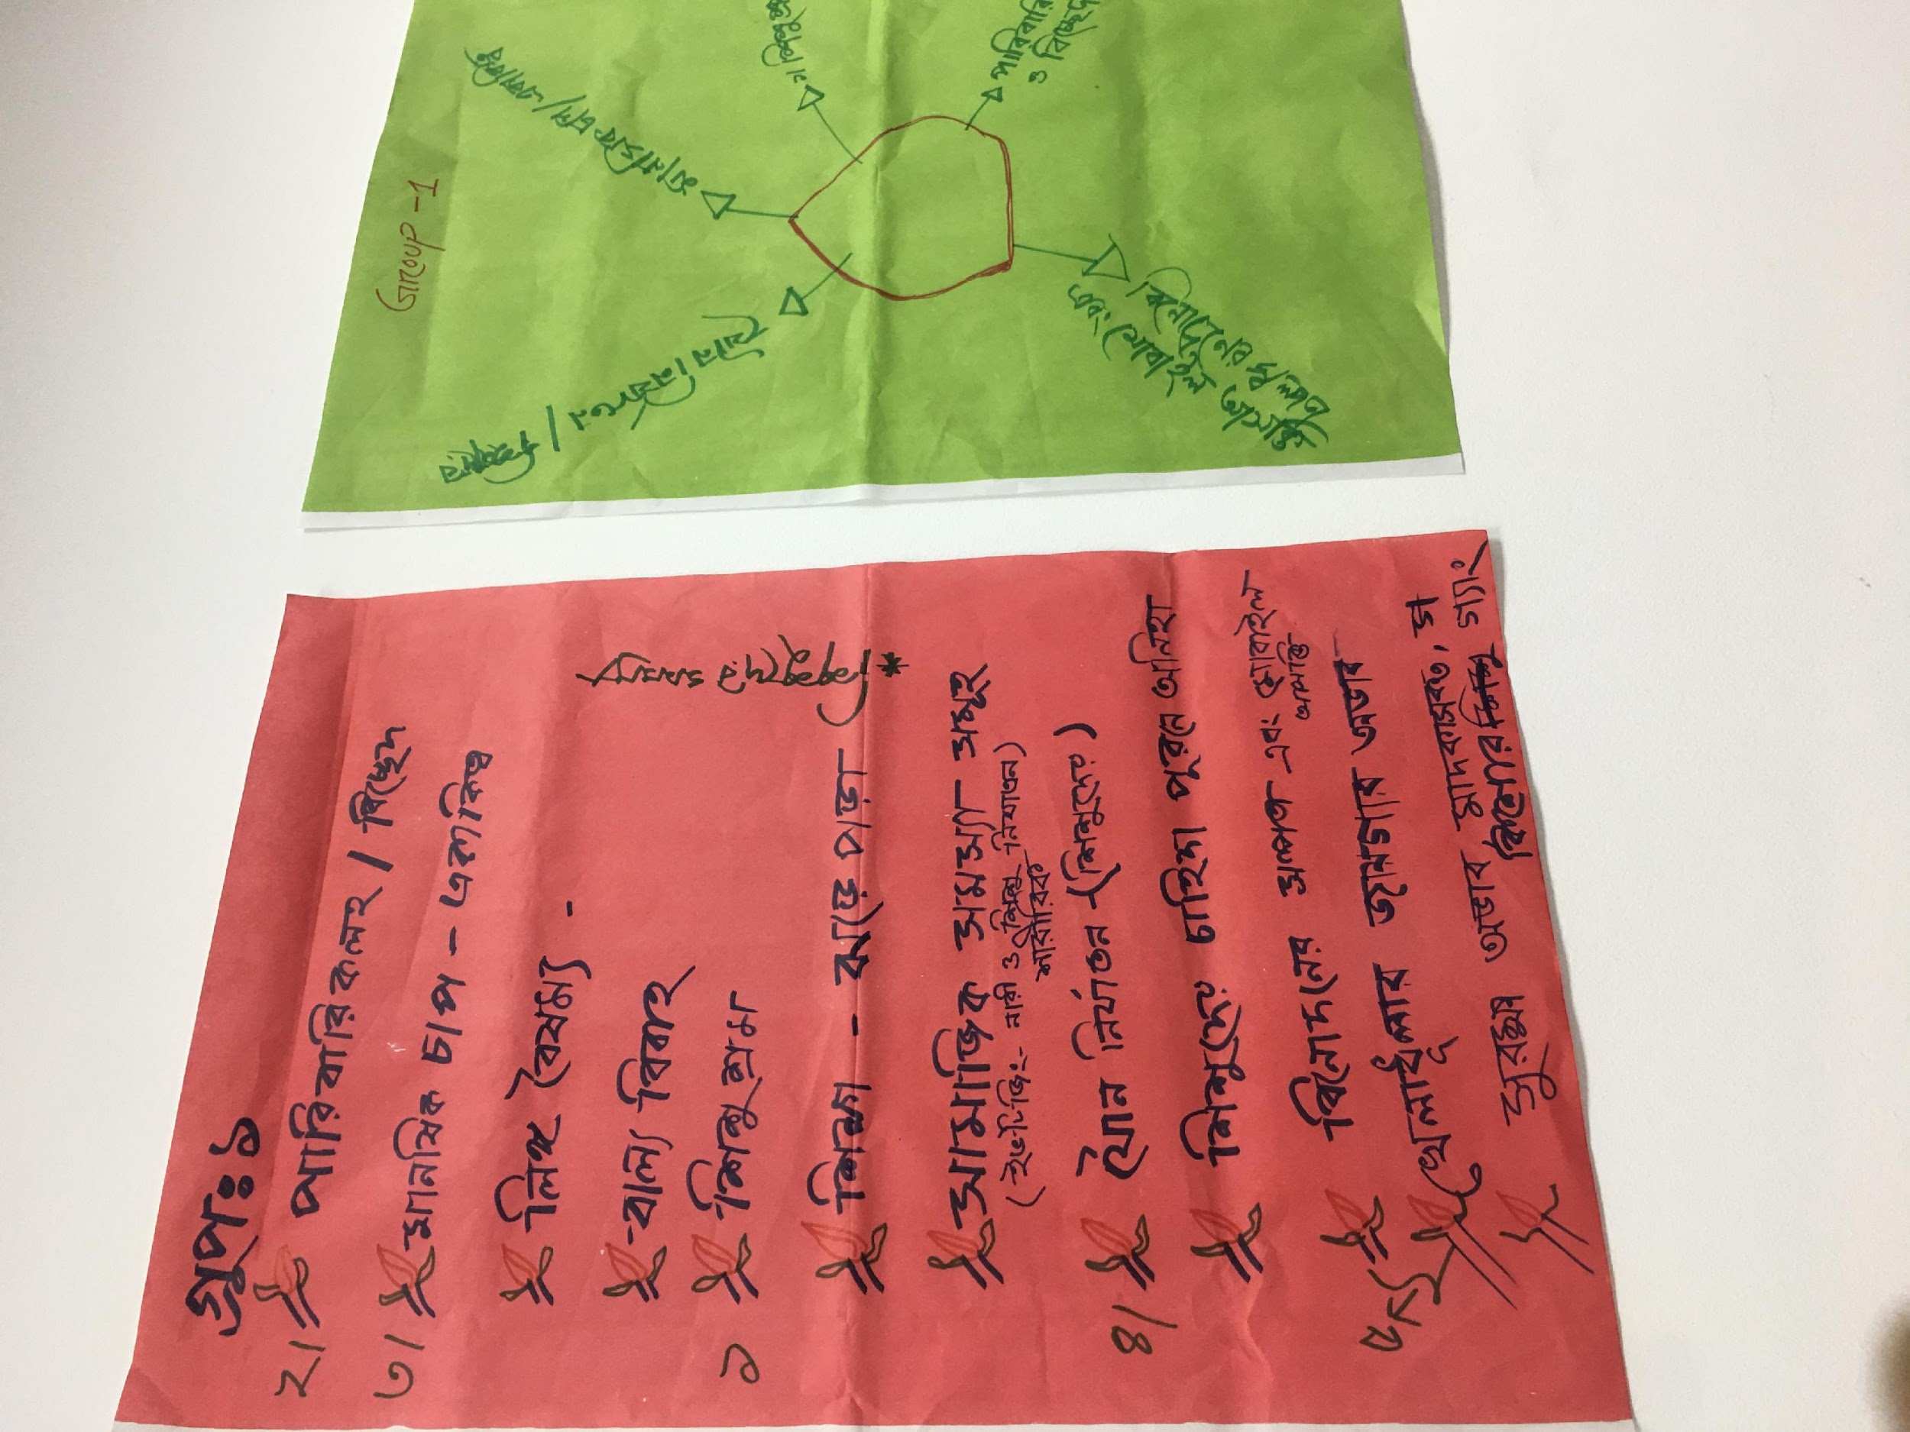
Session 8: Rapport building session with Training participants

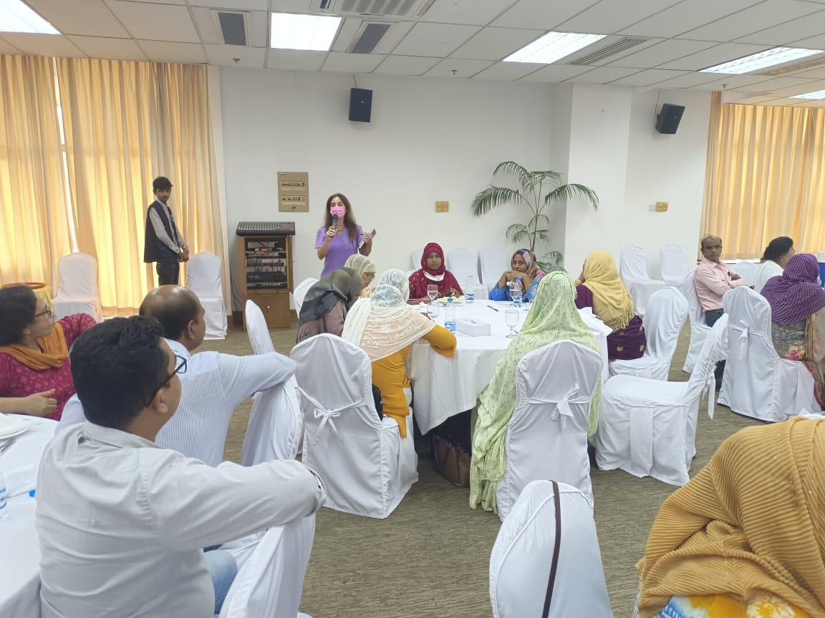 | Elisa Calpona, Child Protection Manager with UNICEF, introduced Child Protection Officers, Child Rights Facilitators, Harmful Practice Coordinators, and VACW Program Coordinators during lunch time for an informal team-building activity among UNICEF Team in Dhaka and Field and MoWCA staff.

Day 4

Session 9: Identifying Children Who Need Help, Building Children’s Strengths, and Getting Involved

The Facilitator conducted this session through role play, where participants were challenged to understand how to protection the child in adverse situations and the role of community members. | 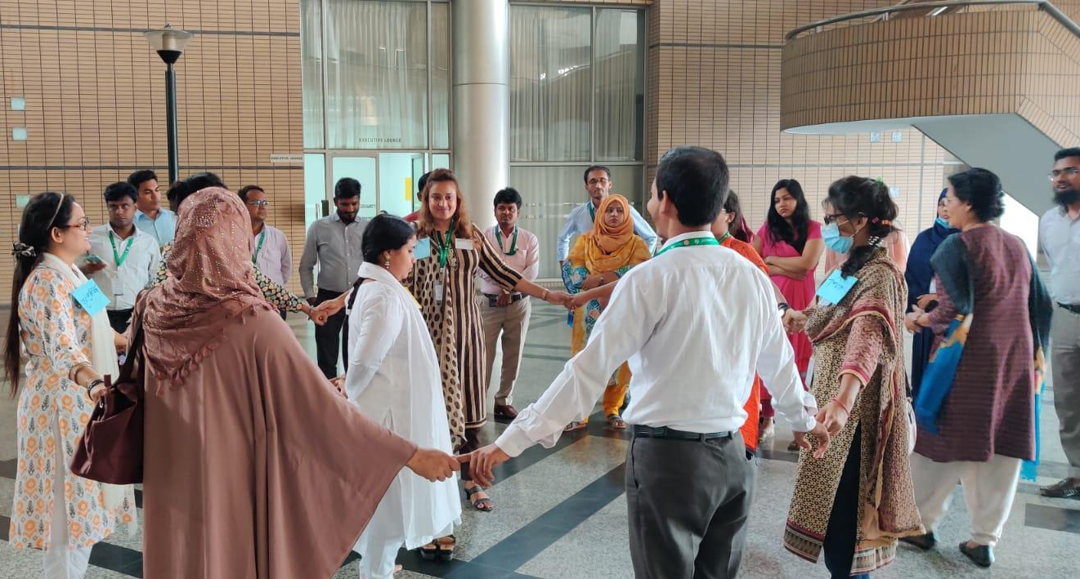

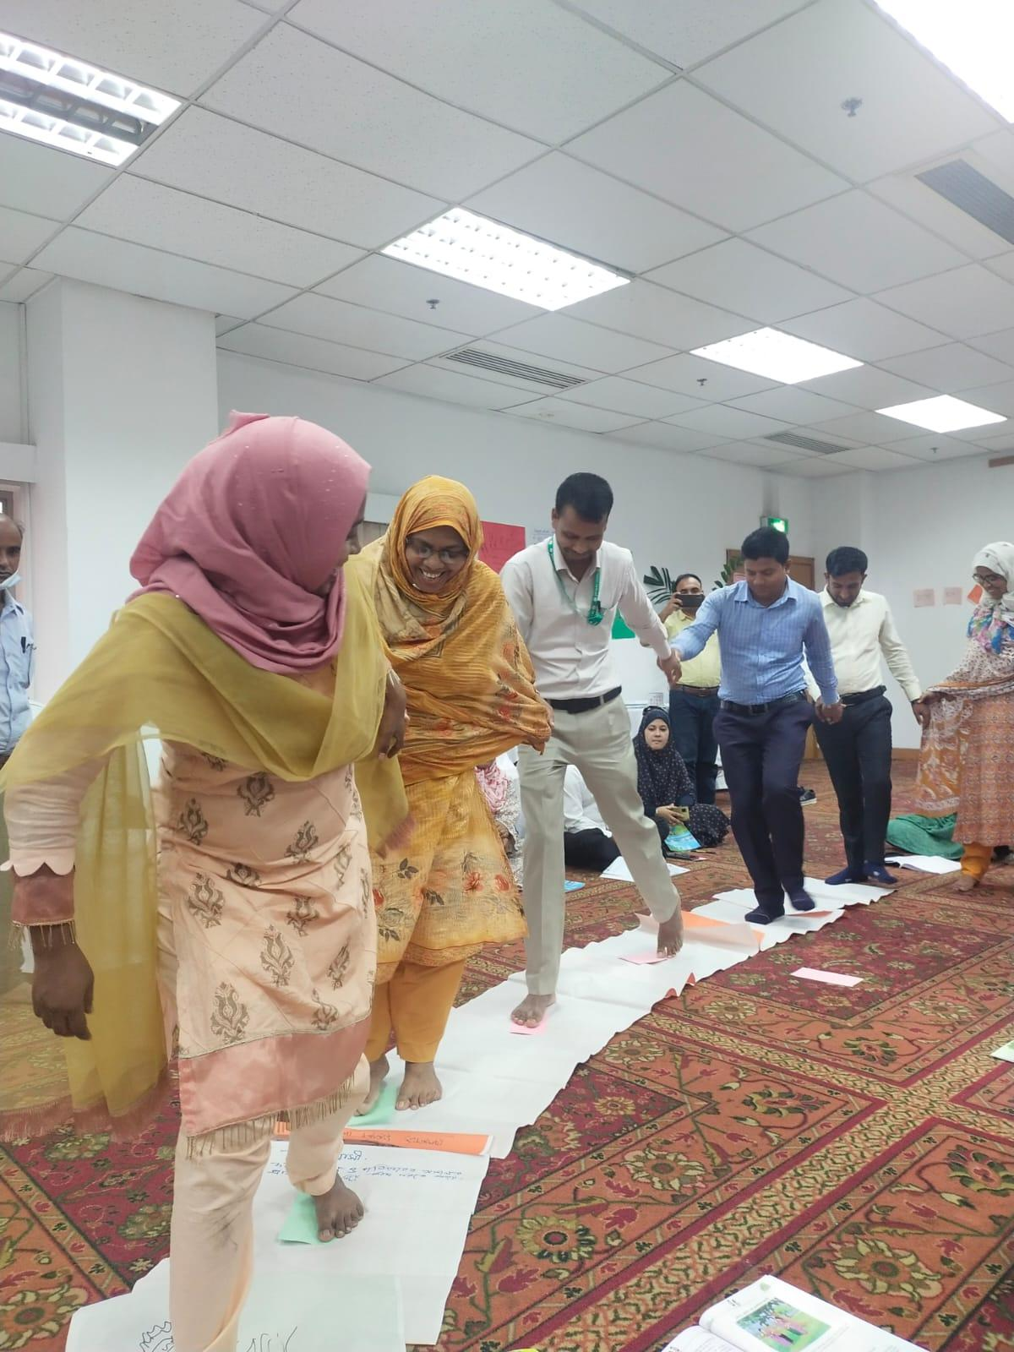 | Next, facilitators shifted to focusing on how to build children’s strengths. The analogy of nourishing a plant was given and participants discussed how to ensure child growth and development.  Next, an activity was facilitated through a ‘crossing the river game’. In first step, participants tried to cross the river as a single community without concerning children, PWD and older people, and participants learned how to deal the crisis by sharing resources.

Session 10: Demonstration by Participants

Participants demonstrated the sessions they had learnt and other participants and the Facilitators provided constructive feedback to participants. Significant feedbacks were;  - Prepare before the session  - Listen to the participants  - Respect the participants  - Facilitate the session as specific to the situation  - Respect local culture, beliefs and values  - Speak in Bangla language  - Dress in a culturally specific way | 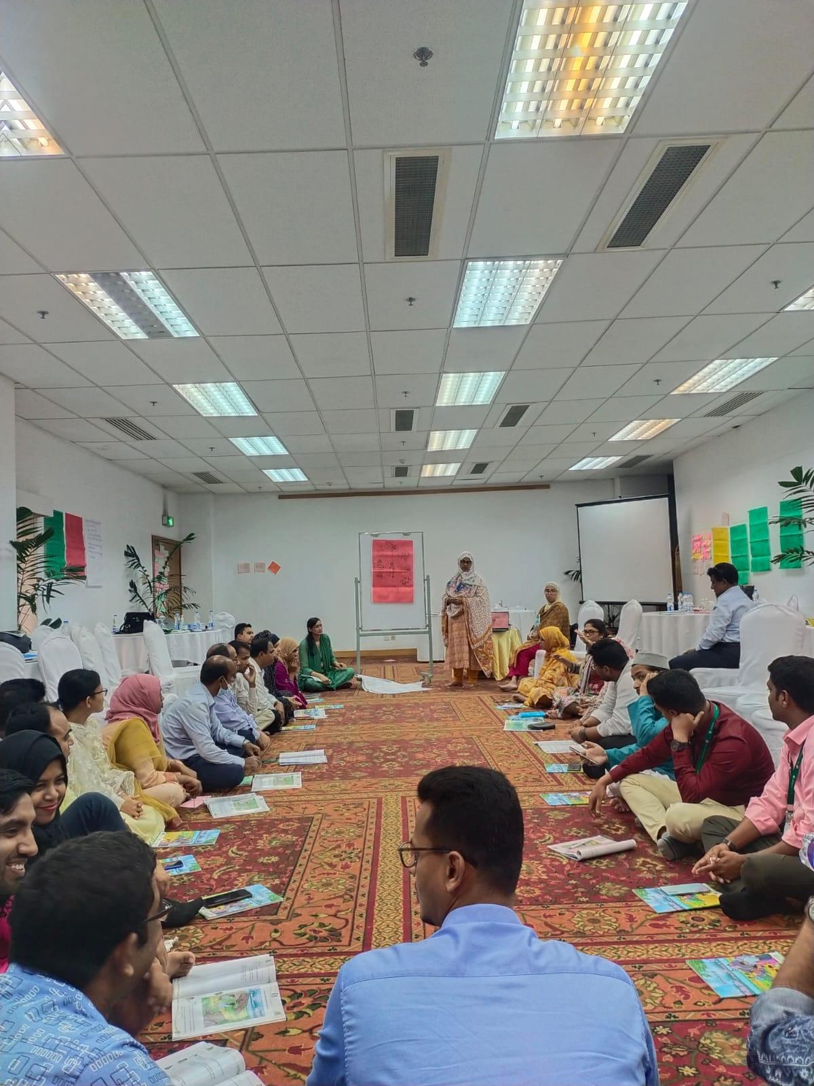

After the demonstration, the session concluded with an evaluation and guidance to develop an action plan facilitate the session at the field level.

Coordination from Central and field team
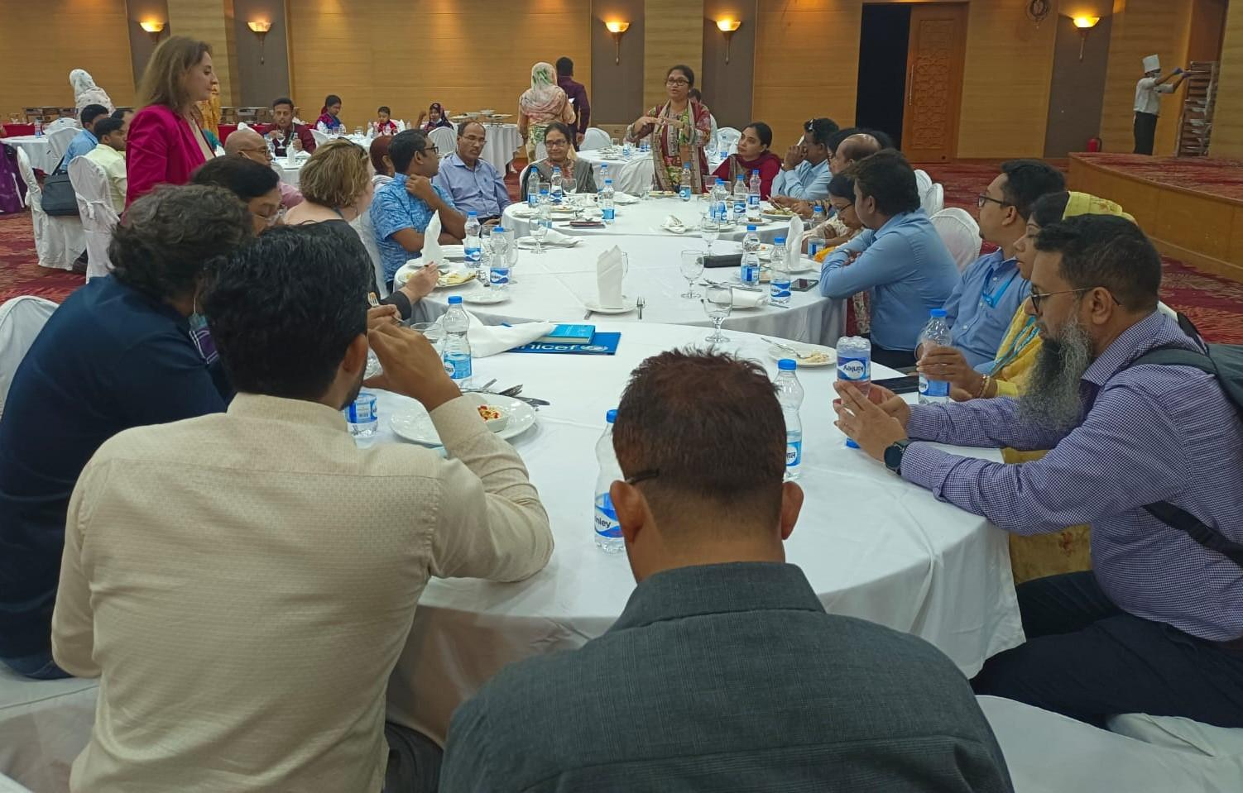
Elisa Calpona (Child Protection Manager and lead for VACW and HP prevention program) chaired a meeting on 28 Sept 2022 with divisional Child Protection Officers (CPOs), Violence against Children and Women Program Coordinators (VACW PCs) in presence of Natalie McCauley (Chief of Child Protection) & Mr. Latif, Project Director, Accelerating Protection for Children Program (APC) project to reinforce the coordination among central and field teams.

Closing Remarks
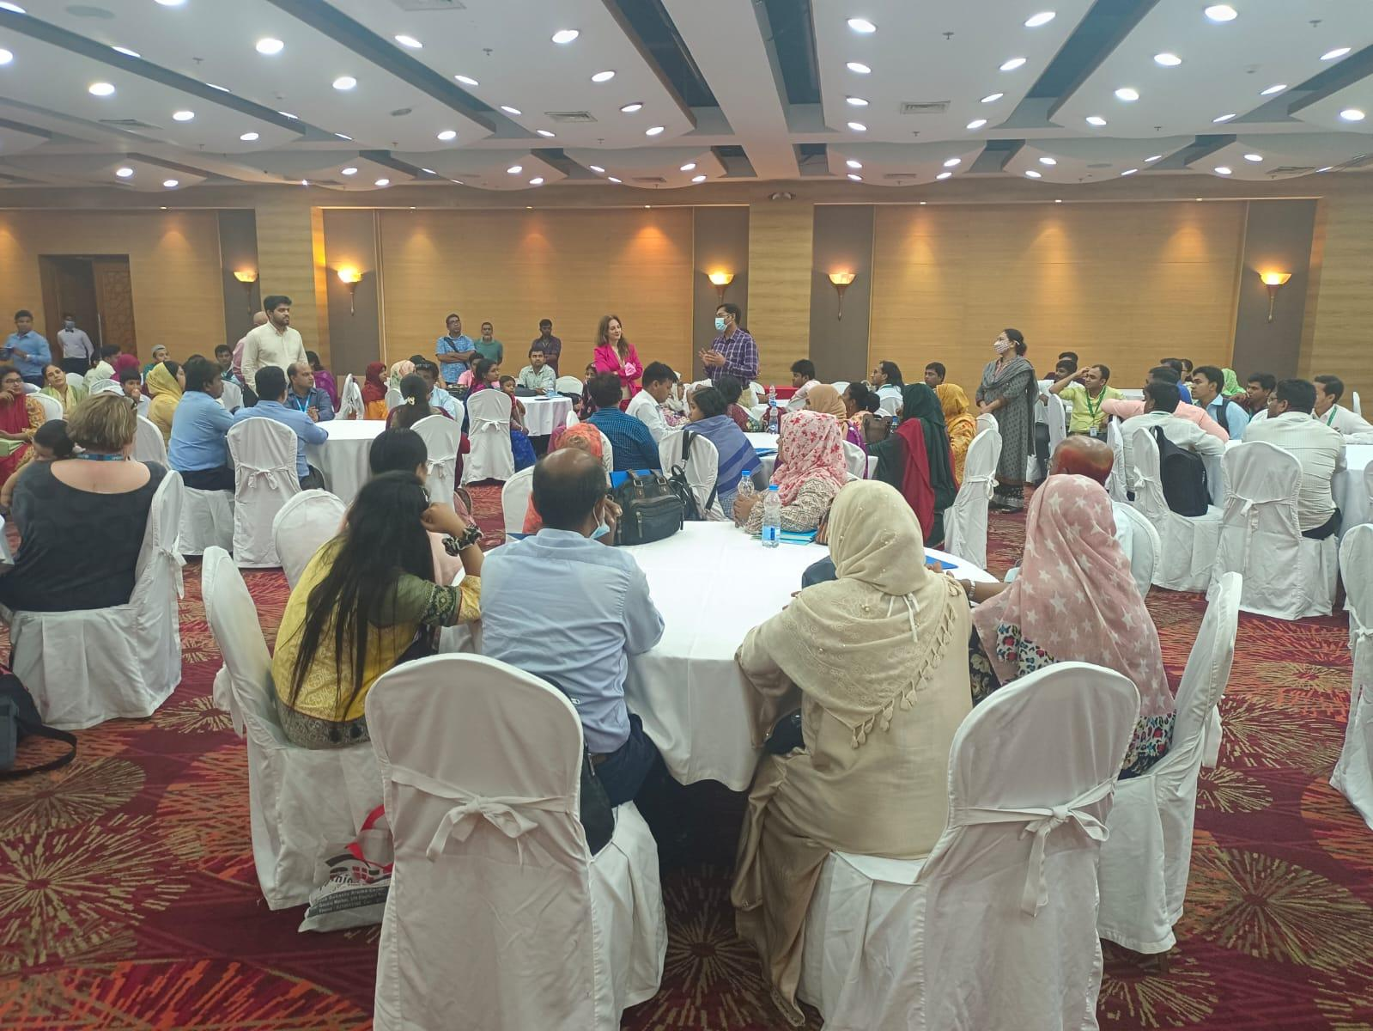
To wrap up the ToT, S.M. Latif, Project Director for Accelerating Protection for Children, thanked every participant for making the event a success. He once again extended his thanks to the EU and UNICEF for supporting the entire program, and also thanked Natalie McCauley for her strategic guidance as the Chief of Child Protection.

